Project Proposal

TITLE

Smart Rent and Share Bicycles

Student Name, Number, email address
Grigor Danut, x16114515, Email: x16114515@student.ncirl.ie

Degree Programme: BSc (Hons) in Computing.
Specialization: Software Development

Date: 27/10/2019

Objectives
(Max. 1 Page)
The application will be called Smart Rent and Share Bicycles and the aim of this project is to build an application that will facilitate the people to rent bicycles made it by a different manufacturer and to share bicycles between different people from different parts of the city. The application will allow the renters to rent and to secure a bicycle and to collect that bicycle from different places of the city where the bicycles are already stored. The number of bicycles available will be maintained by the system and the user will see in real-time the number of bicycles and the availability of the bicycles in each store place. The places where the bicycles are stored will be marked and saved on Google Maps so the users will have the possibility to identify the nearest place where the bicycles stored bicycles and the distance to that place. The application will be addressed to a large number of users of different ages, activities, and hobbies. The share bicycle feature will be designed to allow the users to upload the bicycles available to be shared with details of the time available and the place where the bicycles can be collected and returned.

Background
(Max. 2 Pages)
In the last few years, the demand for bicycles in Dublin and in the other cities has increased continuously and this called Smart Rent and Share Bicycles is designed to meet the requirement of bicycles in Dublin city and in other cities in Ireland. Due to the huge increase in pollution factors, people are encouraged to use bicycles because the activity to ride a bicycle can maintain and improve the health of the user and also can maintain a clean and healthy environment. To investigate the rate of pollution the factors that generate pollution some online researches were made in order to find out the magnitude of this phenomenon. The pollution can be present the major component of the environment such as air pollution, water pollution or ground pollution. The result of researches shows what serious air pollution is in the big cities in the world. The common factors that contribute to air pollution are the burning of vehicle fuels that produce toxic gases that are eliminated in the air. The number of vehicles that are running on the road is increasing every year and then the pollution increased too. The air pollution is very dangerous for the human body and can cause serious chronic respiratory, cardiovascular and lung disease. “The World Health Organization reports that each year 7 million people die prematurely – or one in every nine deaths – are linked to health effects related to indoor and outdoor air pollution. Studies show that air pollution also contributes to climate change; reducing air pollution in London would help slow the effects of global warming.” (Blueair, 2019)

Due to this dramatic effect of pollution, governmental and non-governmental organizations are engaged in a continuous fight against pollution by making studies and elaborate plans and take urgent measures designed to reduce pollution phenomenon. As part of the plan to reduce pollution is to reduce the number of toxic gases eliminate in the atmosphere and this plan can be realized by reducing the number of vehicles that are running on the road every day. The most efficient plan to reduce the number of cars on the road is to encourage people to use a bicycle instead of using a car to do their daily duties such as go to work, or shopping or to do small journeys. Due to the big campaign information about the effect of pollution on Global Warming and the effects on the human body most people are understanding the importance and the benefits of using a bicycle instead of using a car as a means of travel. In the last few years, more and more private companies and governmental organizations were implied in the activities of supplying bicycles to the people. The private companies are renting different models of bicycles to the people who can not afford the money to buy a bicycle and the only solution to ride a bicycle is to rent that bicycle.

Technical Approach
Brief description of the approach to be followed (Max. 1 Page), Research, literature review, requirements capture, implementation, etc…

Research:
The researches were conducted on the internet and the main objectives of researches were to find the number of companies and the variety of bicycles and the services offered by those companies. The findings and the result of the searches were used to outline the main features of the application that already exist in the market and the strength and the weakness of the features of these applications and the way that those features can be improved. As a result of the researches can be enumerated in Dublin is an application platform called Dublinbickes which belongs to the Dublin City Council and offer only one type (mark) bicycle to be rented for a short period of time. The other private companies offer different types (marks) of bicycles.

Requirements Capture:
This stage will involve the researches about some hardware equipment in order to understand the software and hardware requirements that will be used and to ensure the final application will as the way that is designed.
- A Smart Lock/Unlock device will be required to give to the user the possibility to unlock the bicycle via mobile phone.
- A Raspberry PI device will be required to allow the connection between the computer hardware and a Smart Lock/Unlock system

Implementation:
The application will be developed on a website and a mobile application. The website will be administrated by an admin who will maintain the system by checking the number of bicycles rented by users the date and the time the bicycles returned and the technical problems of the bicycles returned. The storage of bicycles and the number of bicycles available in each store will be checked periodically to ensure there are a good number of bicycles available at each store. A store alert will be implemented in order to notify the admin when the number of bicycles available on any store is less than 5 bicycles.

Special resources required
If applicable, e.g., books, hardware, etc.
To finish the project and to make it fully functional the special resources required can be a Raspberry Pi device and a Smart/Wi-fi lock/unlock device that can be controlled via mobile phone.

Project Plan
Gantt chart using Microsoft Project with details on implementation steps and timelines
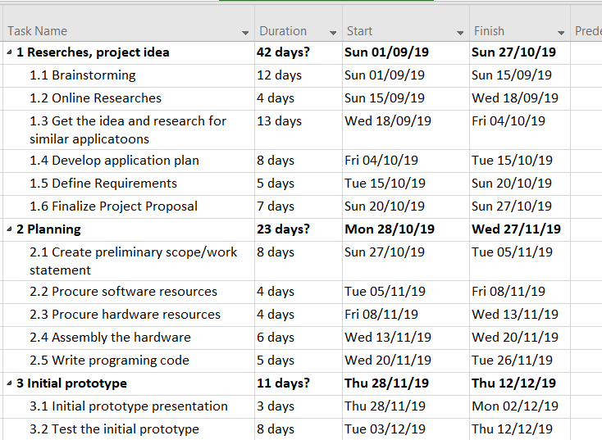

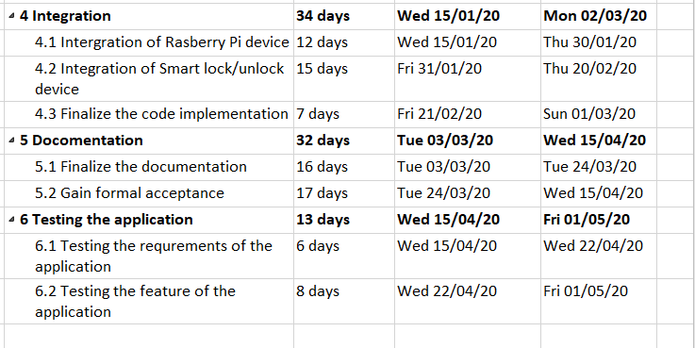

Technical Details
Implementation language and principal libraries

The application will be developed on Android Studio and Firebase database will be used to store and manipulate the information. The principal languages used by Android Studio are XML an Java. To program, the Raspberry Pi the Python programming language will be used.

Evaluation
Describe how you will evaluate the system with real technical data using system tests, integration tests etc. In addition, where possible describe how you will evaluate the system with an end-user. (be careful here re Ethics etc)

The application will be tested by the developer. To ensure the application is fully working the there are no mistakes or errors the application will be download and testes by a number of users who will participate voluntarily in a survey/study to test the application.
The testing will imply:
- Unit testing
- Integration tests
- Acceptance tests

Invention Disclosure Form (Optional – remove if not filled)

References:
Blueair. (2019). Air pollution in big cities. [online] Available at: https://www2.blueair.com/om-ar/london-landingpage [Accessed 26 Oct. 2019].

_____________________27/10/2019
Signature of student and date
https://www.irishexaminer.com/breakingnews/ireland/bike-sharing-removes-five-tonnes-of-carbon-from-dublin-each-year--research-932448.html

